**Assignment – 5**

**Assignment – 5.1**

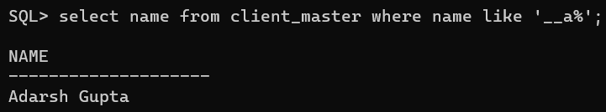

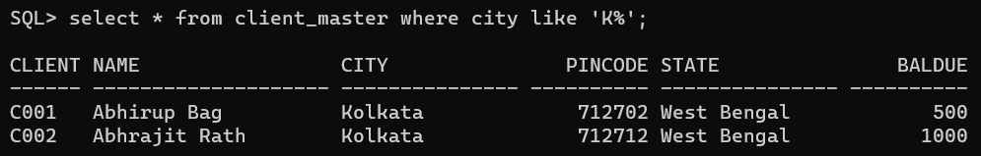

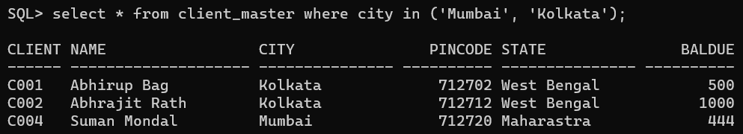

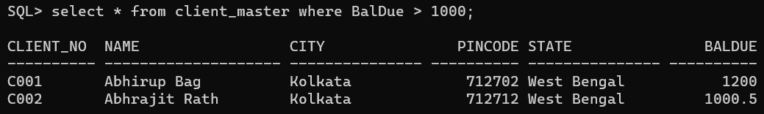

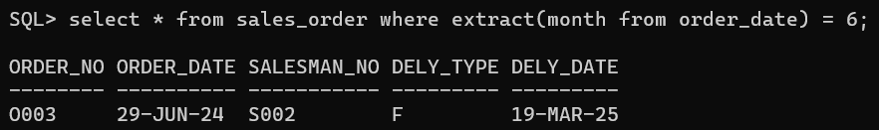

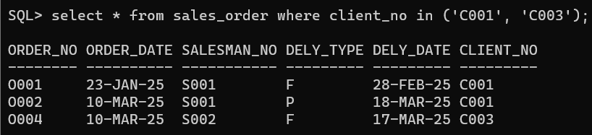

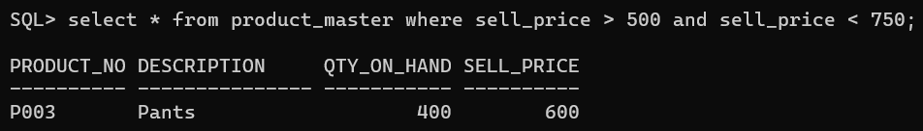

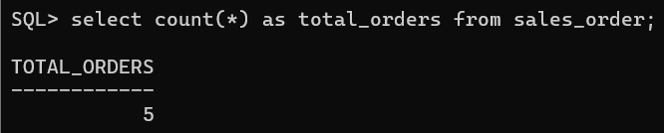

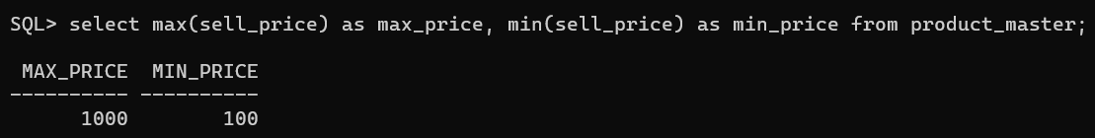

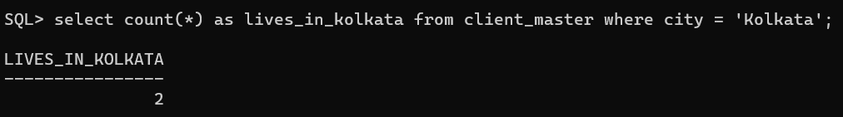

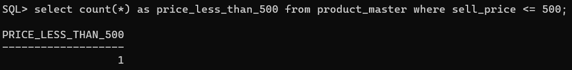

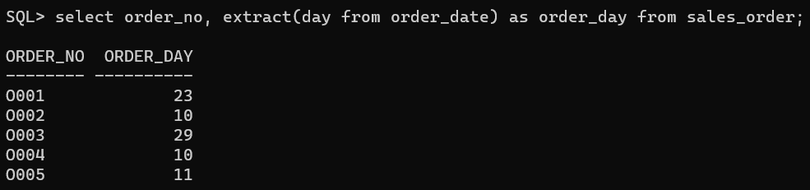

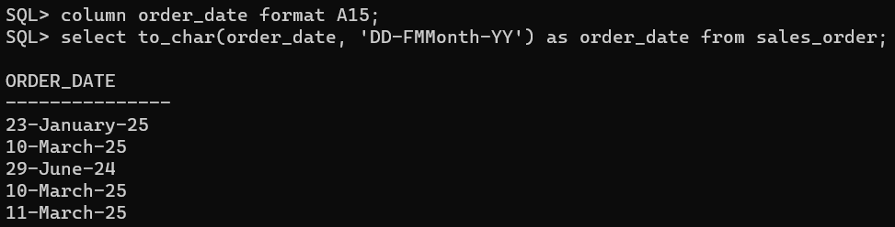

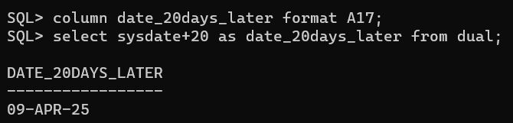

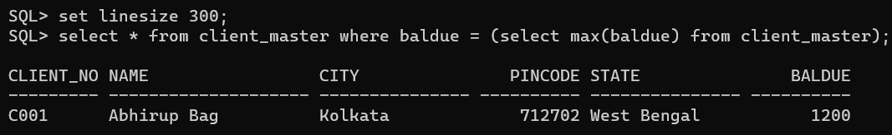

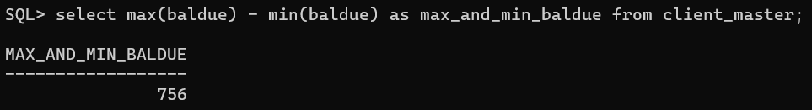

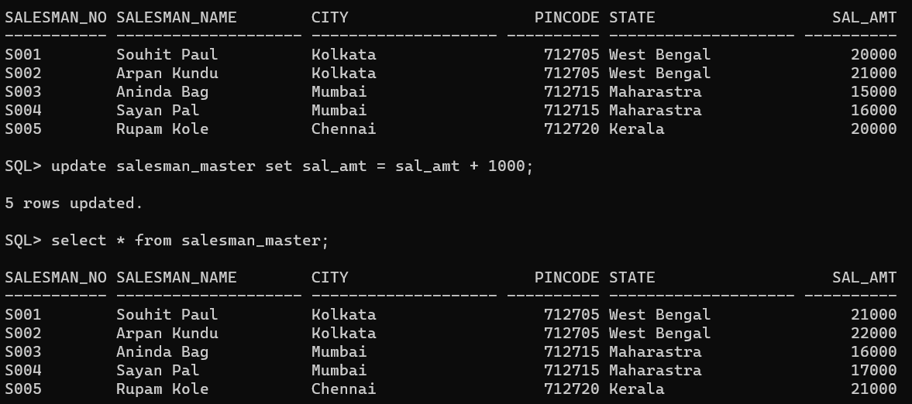

**Assignment – 5.2**

